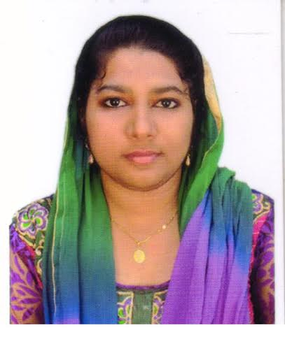**S.SAHINA BARVEEN**

222 pilayar kovil street,

Arulachi,

Sivagiri thaluk,

Tenkasi dist, **Mobile : 9600306220**

TamilNadu **Email id:sahinasulthan2267**@gmail.com

Pincode-627760

**PROFESSIONAL OBJECTIVE**

**PROFESSIONAL OBJECTIVE**

|  |
| --- |
|  |

To gain a dynamic and challenging role in the area of electronics, communication engineering that will offer me the best opportunity for my development of my abilities, skills and knowledge in an established firm with long term career growth possibilities.

**WORK EXPERIENCES**

1. Worked as Embedded Code Designer in ACCEL IT Tirunelveli from may 2015 to April 2016.
2. Worked in PSN Engineering College, Tirunelveli as Asst.Professor in Electronics and communications Department from October 2017 to oct 2019.
3. Worked as QC Trainer at Data Crop Pvt Lmtd, Vasudevanallur, from January 2021 to October 2022.
4. Working as a Soft Skill Trainer at UNNATI for Colleges from from December 2022 to still

**ACADEMIC CHRONICLE**

|  |  |  |  |  |
| --- | --- | --- | --- | --- |
| **COURSE** | **INSTITUTON** | **UNIVERSITY/BOARD** | **YEAR** | **% of Marks** |
| BE | PSN Engineering college, Tirunelveli. | Anna University,  Chennai | 2015 | 82 % |
| HSC | P.L.W.A higher secondary school, Vickramasingapuram. | State board | 2011 | 76 |
| SSLC | P.L.W.A higher secondary school, Vickramasingapuram | State board | 2009 | 90 |

**SOFTWARE EXPOSURE**

* Application software: MS office; proficient in word, Excel , power point and

Embedded coding and decoding.

* HTML,JAVA,JAVA Script
* Programming Language : Basic C,8086 programming language
* Tools worked : MATLAB/PSPICE

|  |
| --- |
|  |

**AREA OF INTEREST**

Electronics Devices& Circuits

Digital Electronics

Control system

**PROJECT DETAILS**

|  |
| --- |
|  |

**PROJECT DURING THE UNDERGRADUATE:**

**POSITION CONTROL OF PMSM USING GAUSSION APPROACH”**

**Field: MATLAB**

**Objective:** This project is used to control the position and speed of the industrial robots.

**CO-CURRICULAR ACTIVITIES**

* Presented paper **on Design of modified dynamic regenerative comparator for power and delay reduction at PSN College of engineering and technology.**
* Presented paper on **Buck Boost Convertor at PSN College of Engineering and Technology in EEE National level Symposium**
* Presented paper at witricity on national level symposium at **Jayaraj anna packiam**
* **Engineering college.**
* Attended implant training **Study of Electronics and communication engineering r elated works at BSNL office** for 1 week.
* Attended workshop program on **embedded** system in **ACCEL IT** academy.
* Attended workshop on **career counseling program** at **Penta CAD software training institute.**
* Attended workshop on **embedded and CAD program in Cad center at Tirunelveli**

**PERSONAL SKILLS**

|  |
| --- |
|  |

* Ability to finish work in time with utmost sincerity.
* Dedicative, hardworking and passionate at work
* One of the organizers of National level conference held in my college.

**PERSONAL PROFILE**

Date of Birth : 06.10.1993

Husband Name : Syed Mohammad pugari.P

Gender : Female

Strength : Confidence, Positive attitude

Linguistic abilities : English(R-W-S), Tamil(R-W-S), Malayalam (S)

Hindi (R-W-S).

**DECLARATION**

I hereby declare that all the details furnished above are true to the best of my knowledge and belief.

**Place:** Tenkasi

**Date:**  (Sahinabarveen.s)